
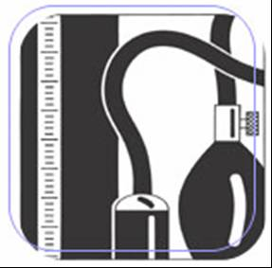
PANAFRICAN PROJECT ON HYPERTENSION
IFHA
INTERNATIONAL FORUM FOR HYPERTENSION CONTROL AND PREVENTION IN AFRICA

NEW AND OLD ANTIHYPERTENSIVE AGENTS IN AFRICAN HYPERTENSIVES (NOAAH) Trial
Ref NOAAH2006XXXXdoc

Introduction and Rationale

Introduction

Sub-Saharan Africa (SSA), is a region plagued by infectious and parasitic diseases, nutritional deficiencies, and excessive maternal-infants morbidity and mortality[1], where the prevention and treatment of cardiovascular diseases (CVD) and risk factors is rarely on the public health agenda[2].
In the Caribbean and sub-Saharan African subjects[3], in those surviving to adulthood, CVD are more than ever the current real public health problem[1, 4-6], and are dominated essentially by hypertension[6, 7]. Although management is assumed to be straight-forward and relatively cheap, appropriate therapy is limited with poor control rates, as in most places[7].
There have been no truly large-scale randomised hypertension trial (RCT) outcome data in Africa itself[4, 5] and little from the Caribbean [6, 8]. We propose a pilot randomized single-blind active-controlled clinical outcome trial to examine whether the key limitation to implementing RCTs in Caribbean and sub-Saharan African settings to date, that of adequate follow-up over a number of years, can now be achieved in several major sites with good basic screening data and previous follow-up experience.

Rationale

- Epidemiological studies have shown biochemical, and hormonal differences between black and white hypertensive subjects [9, 10], as well as their differences in severity and in response to antihypertensive therapy. A variety of genetic and environmental factors have been evoked to account for these differences [9].

- Drugs choice: Insufficient data exists on hypertension therapy in Africa hypertensive subjects, particularly related to therapy efficacy, tolerability and affordability [5]. Convincing evidence from clinical trials has demonstrated a strong relationship between blood pressure (BP) and CVD [5, 11-14], as well as the efficacy of BP treatment to lower CVD risk events [5, 11, 13], especially in Caucasian population. A recent meta-analysis of clinical trials showed that BP reduction, and not the type of drug, is the main factor underlying risk reduction of fatal or non fatal stroke [14]. Importantly, evidence gathered from previous studies indicates that both diuretic and calcium channel blockers (CCB) efficacy was comparable (15-17), especially in stroke risk reduction among black participants (15), however little is known on African continent[15]. The impact of both diuretics and CCB seems to be comparable on CVD risk reduction [13, 16, 17]. Thus choosing those two anti-hypertensive drugs regimens as first-line therapy [12, 13] seems particularly relevant and is in line with the recent guidelines for African countries (5) recommending either diuretics and or CCB as first-line therapy for all black hypertensive patients.

OBJECTIVES

Principal Objective

Evaluating the efficacy of different antihypertensive drugs (including the first-step antihypertensive drug advocated by W.H.O : Amlodipine, hydrochlorothiazide), in Sub-Saharan Africa and Jamaica on basis of standardized and homogeneous protocol as well as the degree of retention and follow up feasibility of a main large scale trial.

Specific objectives

- Efficacy, tolerance and adherence:

  - Evaluate the efficacy of the new and old antihypertensive agents on lowering blood pressure (within and between two drugs treatment arms)

  - Evaluate the tolerance of both two treatment regimens focusing on adverse events

  - Assessing adherence to antihypertensive therapy, as well as the degree of retention in both two arms in one year period

HYPOTHESIS

There are well-described ethnic differences in the prevalence, pathophysiology, severity and management of hypertension, particularly pertaining to the Black populations in Africa, North America, the Caribbean and in Europe [9]. We therefore hypothesize that the response, tolerability and occurrence of CVD events are lower for high-risk black hypertensive patients treated with newer agents (amlodipine, angiotensin II receptors blockers = ARB)[18] compared with a diuretic (amiloride+hydrochlorothiazide) and reserpine regimen.

METHODOLOGY

Design: This is a pilot cohort multicentric randomized parallel single blind active drug controlled trial with intention to treat (ITT). They will be compared with a methodology of a multiple 2x2 factorial clinical trial using the Prospective Randomised Open Blinded Endpoints (PROBE) design. No placebo will be used.

Sampling: To be done with a population based screening study (VITARAA)

Interventions: Two drug treatment arms: one starts with CCB (amlodipine) vs a diuretics therapy (Amiloride + Hydrochlorothiazide). Other medications will be added to achieve goal BP less than 140/90 mm Hg, according to the total trial flow is given in chart n°1

Sample size

The sample size is calculated following series of assumptions:

Sample size needed to show a significant difference in the on-treatment SBP between the 2 treatment groups

Assumption: significance = 0.05 (2-sided), delta = 3 mmHg.

 |  | Between subject standard deviation on the on-treatment BP
 |  | 12 | 14 | 16 | 18
Power | 80 | 253 | 343 | 448 | 567
Power | 90 | 338 | 459 | 599 | 758

Numbers are number of patients required per treatment group. Sample size calculations do not take into account dropouts.

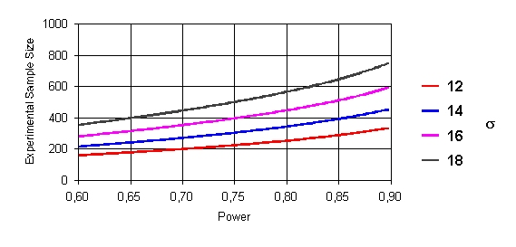

Sample size needed to show equivalence between the 2 treatment groups

Definition of equivalence: less than 3 mmHg difference between the 2 treatment groups

Assumption: significance = 0.05

 |  | Between subject standard deviation on the on-treatment BP
 |  | 12 | 14 | 16 | 18
Power | 80 | 199 | 270 | 353 | 446
Power | 90 | 275 | 374 | 488 | 618

Numbers are number of patients required per treatment group

Sample size calculations do not take into account dropouts.

Definition of equivalence: Difference in response rates between 2 treatment groups less than 8 percent.

 |  | Between subject standard deviation on the on-treatment BP
 |  | 12 | 14 | 16 | 18
Power | 80 | 464 | 484 | 464 | 406
Power | 90 | 643 | 670 | 643 | 563

Numbers are number of patients required per treatment group

Sample size calculations do not take into account dropouts

In conclusion: Considering those all assumption, we judged the total needed sample size is approximately 658 hypertensive patients in all participating countries.

4.2 Study duration: Two years

4.3 Blood pressure Measurement

Conditions of BP measurement will be standardized (see VITARAA protocol), with trained observers.
At least 5 reading will be done, and the 3 last measurements will be averaged.
The BP recording will be done using an electronic validated sphygmomanometer device (OMRON M6; or HEM-7001-E) at the left arm.

4.4 Data handling

Data recording: Following parameters will be recorded in each participant: BP, the heart rate (HR), height, weight and waist, biochemistry measurements (total Cholesterol, HDL-Cholesterol, Na+, K+, blood glucose, and serum creatinin) and haematology. Furthermore, in each participant, urinary sodium excretion, proteinuria, and glycosuria will be screened locally in the sample of fresh urine. In addition, fasting blood samples of 10 ml will be drawn from all participants and will be centrifuged at the data collection site within two hours of its collection. After centrifugation, plasma will be preserved at. -20° for further analysis (polymorphism: 5 ml for DNA).

4.5 Data management: Central data monitoring and local data manager will be set up (KU Leuven).
There will be designed a Local data entry team and website entry, the quality control as well

Subjects Selection

Inclusion criteria:

The fundamental entry criterion is that the patient's own doctor considers there to be no clear indications for, or clear contraindications to, any one of the trial treatments. All subjects will be eligible, provided that:
a. They are able and willing to attend the clinic regularly for at least 12 months.
b. (i) At screening and randomisation they have untreated hypertension with a systolic BP maintained at ≥150mmHg and/or a diastolic BP ≥ 95mmHg;
OR
(ii) At randomisation they have treated hypertension with a systolic BP ≥140mmHg and/or a diastolic BP at ≥90mmHg on ≥ 1 drug.
c. They are aged: ≥40 years.

Exclusion criteria
- Any contraindications to, or previous history of, major intolerance to dihydropyridine calcium channel blockers (CCB's), thiazide diuretics, reserpine and ARB or any others drugs elected in the trial.
- A history of secondary hypertension.
- Malignant hypertension.
- Previous clinical myocardial infarction or currently treated angina pectoris.
- Stroke, transient ischemic attacks, or cerebrovascular surgery <3 months before study onset.
- Patients requiring CCB'S, or diuretics for concomitant diseases or conditions.
- Patients requiring other drugs which are also prescribed for hypertension (eg alpha-blockers for prostatism).
- Second or third-degree A-V block.
- Proteinuria (≥ +)

Patients Visit Schedule : Visit Summary

Period | -4 Weeks  (Wash out) | -2 Weeks  (Wash out) | 0  Randomi-zation | 4 weeks | 8  weeks | 12  weeks | Every month till BP<140/90 mmHg | Every three months | 12  Months  †
Medical History + Physical Examination for Eligibility | X | X | X
Informed Consent | X | X
Parameters recording : Height, Weight, waist | X | X |  |  | X |  |  | X | X
BP, Heart Rate | X | X | X | X | X |  |  | X | X
ECG (optional) | X | X | X |  |  |  |  |  | X
Biochemistry (blood and unrines test) | X | X | X |  | X |  |  | X | X

Antihypertensive regimens

All eligible subjects will be randomised to Step 1 of either regimen A or B (Chart 1). Thereafter progression of subsequent steps will be dependent upon not reaching target pressures (<140mmHg systolic and <90mmHg diastolic for non-diabetics or <130mmHg systolic and <80mmHg diastolic for diabetics).

Chart 1. Antihypertensive regiments and over all flow chart

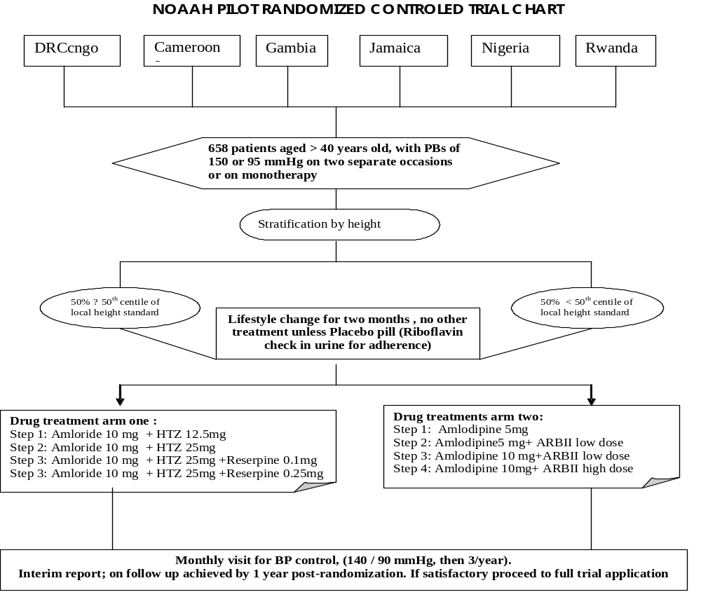

Statistical methods and analysis

For database management and statistical analyses, we will use SAS system, version 9.1
The co-ordinating centre under the supervision of the monitoring center will perform the statistical analyses.

Study Coordination
The study is coordinated by the International Forum for Hypertension control and Prevention (IFHA). In each participating country, national coordinator has the responsibility for local study coordination: 1) recruitment of sites and training of research staff, 2) liaison between study sites and the project Office, 3) Monitoring data collection, storage of blood samples, and their transfer to the project office.

The ethical considerations

This study will be performed in accordance with the Revised Declaration of Helsinki (pages 51-55), and will be compatible with the ICH Harmonised Tripartite Guidelines For Good Clinical Practice (GCP), CPMP/ICH/135/95.

Informed Consent
Subjects who are considered to be eligible for randomisation will have the study explained to them and will be invited to participate after signing an informed consent. A written description of the study will be provided in a patient information sheet. Patients will have an opportunity to initiate any discussion they wish during the initial screening visit, and will have time to think about the invitation to participate in the trial before making a decision. Patients will be discouraged from consenting to participate if it is unlikely that they would wish to contribute for at least 1 year. They will also be informed about a profit from a minimum assessment, in accordance with the IFHA 2003 recommendations and free treatment.

Approval of Institutional Review Board / Ethical committee
The agreement to undertake the study will be required from the ministry of the public health ethic committee council of the each participating country.

Disclosure of data and publication

All information obtained as a result of the study will be regarded as confidential, at least until appropriate analysis and review by the Sponsors and investigator(s) are completed. Permission from the Executive Committee is necessary prior to disclosing any information relative to this study outside of the Steering Committee. The results may be published or presented by the investigator(s), but the executive committee must be informed.

Activities planning
 | 2006 |  | 2007 |  | 2008
 | Jan -Jun | Jul-Dec | Jan-ar | Avr–Dec | Jan | Fev | Mar | Apr | May | Jun
Proposal design and Fundraising
Screening study
Investigators training
Data collection and follow up
Monthly visits
Tri –montly visits
Data entry
Data analysis
Coordination meeeting | 3x | 1x | 1x | 2x | 1x |  |  | 1x | 1x | 1x
Preliminary report
Result publishing

7. SOCIAL RELEVANCE OF NOAAH STUDY
As stressed in introduction, hypertension burden represent a major public health problem in Africa (1), with the particularly to be more prevalent and more severe in black as compared to white subjects. To confront the challenge, cost-effective treatment and preventive strategies are for higher relevant, thus, NOAAH trials follow several promises:
- Building human capacity by training African Doctors and others Healthcare providers in management of Hypertension in cost-effective way.
- The Results of this trial will help setting up practical, context-specific and evidence based guidelines for treatment and control of hypertension in African poor ressource countries.
- The outcomes of NOAAH trial will also provide great tools to guide African health policy

Budget proposal (658 subjects).

For involved countries
 | Unity | U.P Euros (€) | Quantity |  | T.P in Euros (€) | Observations
 |  |  | Number | Time (in months)
Personnel (Work on contract)
Principal investigator | person | 1.500 | 1 | 15 | 22.500 | Half - time
Associate investigators | person | 1.000 | 1 | 15 | 15.000 | Half - time
Nurses | person | 500 | 2 | 12 | 12.000 | Half - time
Local Logistics staff (secretary, accountant, data entry) | person | 500 | 3 | 6 | 9.000 | Half - time
Local Data handeling center (Office related fees) |  | 1.000 | 1 | 24 | 24.000 | Permanent
 |  |  |  | Subtotal 1 | 82.500
Laboratory fees
Blood sample analysis (risk factors) | sample | 100 | 165 |  | 16.500 | Locally
 |  |  |  | Subtotal 2 | 16.500
Equipment
Transport allowances for patients | Per month per pers | 15 | 165 | 12 | 29.700
Laptop | piece | 2.000 | 1 |  | 2.000
Desktop PC | piece | 1.500 | 2 |  | 3.000
Sphygmomanometers | piece | 100 | 15 |  | 1.500
Scales | piece | 100 | 15 |  | 1.500
Height apparatus | piece | 100 | 15 |  | 1.500
Office furniture |  | 1.500 | 1 |  | 1.500
Transport of materials |  | 1.500 | 1 |  | 1.500
 |  |  |  | Subtotal 3 | 42.200
Meetings and associate logistics
Transport & Flight tickets for Executive committee | Travels / Person | 3.000 | 1 | 4 | 12.000
Initiating meetings (1)+ Monitoring meeting (6) | 1 meeting | 1.000 | 7 |  | 7.000
Investigators training meeting | 1 meeting | 5.000 | 4 |  | 20.000
 |  |  |  | Subtotal 4 | 39.000
Any other busines
Post fees, questionnaire printing, etc | times | 1.000 | 1 |  | 1.000
Unforeseen |  | 2.500 | 1 |  | 2.500
 |  |  |  | Subtotal 5 | 3.500
 |  |  |  | TOTAL | 183.700
TOTAL FOR ALL INVOLVED COUNTRIES |  |  | 4 |  | 734.800

For coordination center (Overall)
 | Unity | U.P Euros (€) | Quantity |  | T.P in Euros (€) | Observations
 |  |  | Number | Time (in months)
Personnel (Work on contract)
Principal investigator (Chair of Excecutive com) | person | 1.500 | 1 | 15 | 22.500 | Half - time
Associate investigators (Co-chairs) | person | 1.000 | 2 | 15 | 30.000 | Half - time
Logistics staff (secretary, accountant, data entry) | person | 1.500 | 3 | 6 | 27.000 | Half - time
Data managment and statistics center (Coordination) | Bunch fees | 2.500 | 1 | 24 | 60.000 | To be discussed
Monitoring center |  | 10.000 |  |  | 10.000 | Contract
 |  |  |  | Subtotal 1 | 149.500
Laboratory fees
Blood sample analysis (risk factors) | sample | 100 | 658 |  | 65.800
 |  |  |  | Subtotal 2 | 65.800
Equipment
Drugs (Monthly dosis per patient) | Per month per pers | 52 | 658 | 12 |  | To be discussed (410'592 Euros)
Laptop | piece | 1.500 | 2 |  | 3.000
Office furniture |  | 1.500 | 1 |  | 1.500
Transport of materials |  | 1.500 | 1 |  | 1.500
 |  |  |  | Subtotal 3 | 6.000
Meetings and associate logistics
Transport & Flight tickets for Executive committee | Travels / Person | 3.000 | 7 | 4 | 84.000
Initiating meetings (1)+ Monitoring meeting (3) | 1 meeting | 1.000 | 4 |  | 4.000
Results presentation meeting (validation) | 1 meeting | 15.000 |  |  | 15.000
 |  |  |  | Subtotal 4 | 103.000
Any other busines
Post fees, questionnaire printing, etc | times | 1.000 | 1 |  | 1.000
Unforeseen |  | 2.500 | 1 |  | 2.500
 |  |  |  | Subtotal 5 | 3.500
TOTAL |  |  |  | TOTAL | 327.800
Total Budget for the Project (Aggregate of countries budget + Coordination) |  |  |  |  | 1.062.600

NB: This total doesn’t include drugs fees estimated to 410’592 Euros for 658 patient’s receiving drugs in 12 months period. The drug’s price is estimated to 52 Euros per month par patient (patients will receive treatment free of charge)

References

1. WHO. The World Health Report 2003. World HealthOrganization 2003; 182-184-156-158.
2. Mensah GA. A heart-healthy and "stroke-free" world through policy development, systems change, and environmental supports: a 2020 vision for sub-Saharan Africa. Ethn Dis 2003; 13(2 Suppl 2):S4-12.
3. Cruickshank JK, Mbanya JC, Wilks R, Balkau B, Forrester T, Anderson SG, et al. Hypertension in four African-origin populations: current 'Rule of Halves', quality of blood pressure control and attributable risk of cardiovascular disease. J Hypertens 2001; 19(1):41-46.
4. Seedat YK. Hypertension in developing nations in sub-Saharan Africa. J Hum Hypertens 2000; 14(10-11):739-747.
5. Lemogoum D, Seedat YK, Mabadeje AF, Mendis S, Bovet P, Onwubere B, et al. Recommendations for prevention, diagnosis and management of hypertension and cardiovascular risk factors in sub-Saharan Africa. J Hypertens 2003; 21(11):1993-2000.
6. Kearney PM, Whelton M, Reynolds K, Muntner P, Whelton PK, He J. Global burden of hypertension: analysis of worldwide data. Lancet 2005; 365(9455):217-223.
7. Whitworth JA. World Health Organization (WHO)/International Society of Hypertension (ISH) statement on management of hypertension. J Hypertens 2003; 21(11):1983-1992.
8. Wright JT, Jr., Dunn JK, Cutler JA, Davis BR, Cushman WC, Ford CE, et al. Outcomes in hypertensive black and nonblack patients treated with chlorthalidone, amlodipine, and lisinopril. JAMA 2005; 293(13):1595-1608.
9. Falkner B. Differences in blacks and whites with essential hypertension: biochemistry and endocrine. State of the art lecture. Hypertension 1990; 15(6 Pt 2):681-686.
10. Lenfant C, Chobanian AV, Jones DW, Roccella EJ. Seventh report of the Joint National Committee on the Prevention, Detection, Evaluation, and Treatment of High Blood Pressure (JNC 7): resetting the hypertension sails. Hypertension 2003; 41(6):1178-1179.
11. Collins R, Peto R, MacMahon S, Hebert P, Fiebach NH, Eberlein KA, et al. Blood pressure, stroke, and coronary heart disease. Part 2, Short-term reductions in blood pressure: overview of randomised drug trials in their epidemiological context. Lancet 1990; 335(8693):827-838.
12. Materson BJ, Reda DJ, Cushman WC, Massie BM, Freis ED, Kochar MS, et al. Single-drug therapy for hypertension in men. A comparison of six antihypertensive agents with placebo. The Department of Veterans Affairs Cooperative Study Group on Antihypertensive Agents. N Engl J Med 1993; 328(13):914-921.
13. Psaty BM, Smith NL, Siscovick DS, Koepsell TD, Weiss NS, Heckbert SR, et al. Health outcomes associated with antihypertensive therapies used as first-line agents. A systematic review and meta-analysis. JAMA 1997; 277(9):739-745.
14. Staessen JA, Wang JG, Thijs L. Cardiovascular protection and blood pressure reduction: a meta-analysis. Lancet 2001; 358(9290):1305-1315.
15. Khder Y, Bray des BL, el GR, Meilhac B, Montestruc F, Stoltz JF, et al. Calcium antagonists and thiazide diuretics have opposite effects on blood rheology and radial artery compliance in arterial hypertension: a randomized double-blind study. Fundam Clin Pharmacol 1998; 12(4):457-462.
16. Mancia G, Brown M, Castaigne A, De LP, Palmer CR, Rosenthal T, et al. Outcomes with nifedipine GITS or Co-amilozide in hypertensive diabetics and nondiabetics in Intervention as a Goal in Hypertension (INSIGHT). Hypertension 2003; 41(3):431-436.
17. The ALLHAT Officers and Coordinators for the ALLHAT Collaborative Research Group. Major outcomes in moderately hypercholesterolemic, hypertensive patients randomized to pravastatin vs usual care: The Antihypertensive and Lipid-Lowering Treatment to Prevent Heart Attack Trial (ALLHAT-LLT). JAMA 2002; 288(23):2998-3007.
18. MacGregor GA, Viskoper JR, Antonios TF, He FJ. Efficacy of candesartan cilexetil alone or in combination with amlodipine and hydrochlorothiazide in moderate-to-severe hypertension. UK and Israel Candesartan Investigators. Hypertension 2000; 36(3):454-460.

